

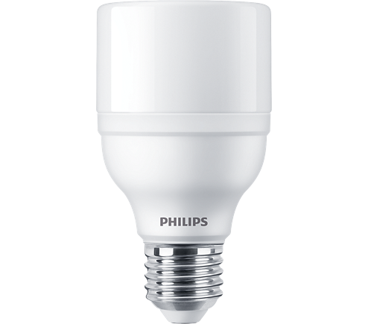

LED BULB

* 11W-80(80W GLS, 20W CFL)W
* E27
* White

**Rs 280.00**